**CHAPTER 1**

**INTRODUCTION**

**Overview**

An Automated Teller Machine (ATM) allows customers to perform banking transactions any and at any time without the need of human teller. By using a debit or ATM card at an ATM, individuals can withdraw cash from current or savings accounts, make a deposit or transfer where money from one account to another or perform other functions.

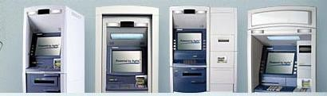

Automated teller machines is almost a direct currency dispenser terminal permitting the client to directly get the money, however a while thanks to lack of security in some way or the other, some unauthorized user or hackers or criminals take an opportunity to tamper the machine and steal the money by physical attacks on Automated teller machines and by tampering with the machine, cutting the safe, bombing, shoulder surfing, ram riding are the other common abuse of Automated teller machines by the frauds. There are several criminal attacks on Automated teller machines’ involving hold-up, removal of Automated teller machines from its premises by force, or by assault to the Automated teller machines within the premises with safe-breaking instrumentally or by explosives.

For the past several decades‟ easy access, secure storage of money was a problem for humans. Then came a solution to that problem. Banks provided an ATM card with which we can withdraw money from our account. Each person was given a set of cards, but those cards were only for one time use. Each time a person withdraws money from his/her account, the card is punched making it unusable. So the introduction and concept of those cards was did not last long because, each time the card runs out they have to go to the bank requesting a set of new cards. Then came the modern ATM cards, which have a magnetic strip on the back side of it. Each person‟s account will have a unique ATM card which has a unique set of codes behind the magnetic strip. The codes are ciphered. When inserted into an ATM (Automated Teller Machine) machine, a scanner scans the ciphered codes behind the magnetic strip. It then asks for a four digit PIN code which is kind of a password for protecting our account. It matches the PIN with the database and if the codes are matched then, we will be able to access our account. But if the PIN number does not match them self then we won‟t be able to access our account. This is the current technology which is present regarding ATM transactions.

In the majority of attempts of attacks, the criminal has gained success of varying degree. To safeguard from this sort of frauds some security features are being added/created for Automated teller machines from time to time but these security features gets holed by thecriminals. Wayside cheaters and gangster used to loot money from victims at deserted/isolated places by nabbing the passerby, with introduction of Automated teller machine, they did find small money or no money from the victims. Since they noticed that invariably all the victims had ATM cards with them, they added the practice of forced withdrawal from the victims from ATM cards. Gangster either wait in Automated teller machine kiosks for the victim as if they are waiting to withdraw the money or nab a victim at deserted place and bring the victims to Automated teller machine kiosks and force the victim at knife point or gunpoint to use his ATM card and withdraw the money from the Automated teller machine using ATM card and his PIN number.

The class Card input has the methods for reading the code of the client's card and for ejecting the card from the ATM. The class Card input will interact through the Controller with the class Terminal, where the methods Required PIN and Required amount are defined, in order to get the PIN of the user and to verify if the given PIN is correct or not.

**EXISTING METHODS**

In the literature of abnormal event detection, most of the methods as in uses classifiers to recognize the events and does not use video input. These classifiers require learning time and careful attention on training dataset. Some approaches require manual setup initially in the automated event detection system and have high computational cost. From the literature we come to the fact that we need an algorithm which deals with uncommon even detection in video to assist a fully automated surveillance system.

**Proposed system**

Proposed system can use a low resolution USB camera however we have utilized the web camera for the prototype. Web camera will stream the live video and frames will be captured for image processing. We are using Open CV , open source image processing algorithms for our design.

The unusual activity inside the ATM is observed for the proposed design using listed algorithm below. The listed algorithm is very simple and can be enhanced by adding more features as the need arises by training our own classifiers. Algorithm to detect unusual activity:

* Person who has entered into the ATM face is detected by face recognition features.
* If his/her face is covered by helmet or any other things while using ATM which will make it difficult to recognize his face then it will be treated as unusual activity.
* The person is inside ATM without initiating any activity for certain amount of time then a threshold time is set & if the person is inside the ATM room above the threshold time then an alarm message for the Security guard is issued to monitor his behavior on screen.
* If more than one face is detected then it is considered as Unusual Activity. This is done to avoid robbery inside the ATM room.

**HISTORY OF ATM**

As is often the case with inventions, many inventors contribute to the history of an invention. In the case of the ATM, Don Wetzel invented the first successful and modern ATM in the USA, however he was not first inventor to create an ATM. In 1939, Luther George Simian started patenting an earlier and not-so-successful version of an ATM.

An automatic teller machine or ATM allows a bank customer to conduct their banking transactions from almost every other ATM machine in the world. Don Wetzel was the co-patentee and chief conceptualist of the automated teller machine, an idea he said he thought of while waiting in line at a Dallas bank.

At the time (1968) Wetzel was the Vice President of Product Planning at Ductal, the company that developed automated baggage-handling equipment. The other two inventors listed on the patent were Tom Barnes, the chief mechanical engineer and George Chastain, the electrical engineer. It took five million dollars to develop the ATM. The concept of the modern ATM first began in 1968, a working prototype came about in 1969 and Ductal was issued a patent in 1973.

The first ATMs were off-line machines, meaning money was not automatically withdrawn from an account. The bank accounts were not (at that time) connected by a computer network to the ATM. Therefore, banks were at first very exclusive about who they gave ATM privileges to.

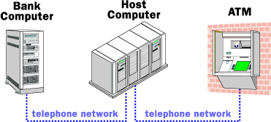**HOW ATMS WORK**?

Fig1.2: Operation of ATM

An ATM is simply a data terminal with two input and four output devices. Like any other data terminal, the ATM has to connect to, and communicate through, a host processor. The host processor is analogous to an Internet Service provider (ISP) in that it is the gateway through which all the various ATM networks become available to the cardholder (the person wanting the cash).

Most host processors can support either leased-line or dial-up machines. Leased-line machines connect directly to the host processor through a four-wire, point-to-point, and dedicated telephone line. Dial-up ATMs connect to the host processor through a normal phone line using a modem and a toll-free number, or through an Internet service provider using a local access number dialed by modem.

**WHY GO FOR ATM?**

An automatic teller machine increases existing business. The typical ATM customer will spend 20-25% more than a non-ATM customer, according to research conducted by AT&T Global Information Solutions. An automatic teller machine generates new business. Customers are more likely to seek out a location with an automatic teller machine; in addition to convenience, there are a number of safety benefits associated with an in-store automatic teller machine, according to survey results published in Petroleum Marketer magazine.

An automatic teller machine provides additional revenue streams. Each ATM withdrawal transaction generates surcharge ("convenience fee") income for the owner of the automatic teller machine. Additionally, an automatic teller machine can provide revenue from on-screen advertising, couponing, and alternative media (e.g., prepaid phone-cards, postage stamps) dispensing opportunities.

An automatic teller machine reduces risk and lowers costs. Having an automatic teller machine on the premises can reduce the number of bad checks and cut credit card expenses because customers have the option of withdrawing cash instead.

**TYPES OF ATM ATTACK ON ATM**

There are a variety of ATM attacks because it is such an attractive target. There are three basic types of ATM attacks：

1) **Physical attack**: Brute force attack to ATM machines with the intention of gaining access to cash within the safe.

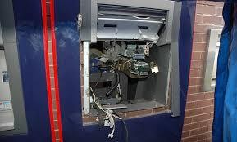

Fig 1.3: physical attack on ATM

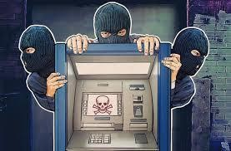2) **ATM Fraud**: the gang will remove the device with the cash still glued on it.

Fig 1.4: fraud attack on ATM

3) **Software and network attack:** Theft of sensitive information or controlling ATM spew out bills automatically



Fig 1.5: software attack on ATM

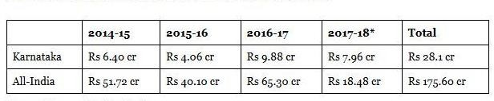**MONEY LOST BY ATM ATTACKS**

**TABLE 1: Detail about money lost on ATM**

In the past few decades, significant efforts in the field of moving object detection and tracking have been done to make following applications reliable, robust and efficient: video surveillance, robotics, authentication system, media production, biological research etc. But there are many challenges which produce hurdles in the improvement of these applications. These challenges may include illumination change, dynamic background, camouflage, occlusion, shadow etc. These obstacles become more cumbersome when we perform object tracking in low resolution video. In low resolution video it is very difficult to accurately find out the object of interest because most of the discriminative details such as visual features and primitives have been lost. It results in inaccurate object tracking which further lead to inefficient event detection. But there are certain benefits of using low resolution video such as it requires low storage, transmission time and processing time.

**CHAPTER 2**

**LITERATURE SURVEY**

**[1] Unusual Event Detection in Low Resolution Video for enhancing ATM security**

**Authors: SudhirGoswami, JyotiGoswami, Nagresh Kumar**

**Published in: 2nd International Conference on Signal Processing and Integrated Networks (SPIN), 2015.**

**Methodology:**Proposed algorithm only uses close morphological operation with disk like structuring element in the preprocessing steps to cope up with low resolution video. It further uses rolling average background subtraction technique to detect foreground object from dynamic background in a scene. Our proposed algorithm is able to recognize the occurrence of uncommon events such as overcrowding or fight in the low resolution video simply by using statistical property, standard deviation of moving objects.

**Merits:**It is fast enough because it process low resolution frames and could be helpful in surveillance system for enhancing the security of ATMs where conventional camera of low resolution are still used

**Demerits:**. It does not use any classifier and avoids the requirement of training the system initially.

**[2] Smart unusual event detection using low resolution camera for enhanced security**

**Authors:Saleem Ulla Shariff ; MaheboobHussain ; Mohammed FarhaanShariff**

**Published in:2017 International Conference on Innovations in Information, Embedded and Communication Systems (ICIIECS), 17-18 March 2017**

**Methodology:**We are proposing an Enhanced ATM security system by proposing a system to detect unusual event detection even in the low resolution videos using ARM 7 LPC 2148. The low resolution camera fitted inside ATM can be used. We are using the inbuilt web camera of the PC or Laptop in designing of the prototype. Usually the laptop inbuilt web camera resolution is low. Hence we use the same. By using discussed algorithm we design a system to detect the unusual activity. Whenever an Unusual event gets detected in ATM then buzzer will be on and also Alert SMS triggering happens from the GSM module to which ARM 7 sends the appropriate commands. **Merits:**These alert SMS will be sent to the Level 1 and level 2 security guards mobile number.

**Demerits:** Low cost effectives

**[3] Face detection based ATM security system using embedded Linux platform**

**Authors: Jignesh J. Patoliya ; Miral M. Desai**

**Published in: 2017 2nd International Conference for Convergence in Technology (I2CT), 7-9 April 2017.**

**Methodology:**The system is implemented on the credit card size Raspberry Pi board with extended capability of open source Computer Vision (Open CV) software which is used for Image processing operation. High level security mechanism is provided by the consecutive actions such as initially system captures the human face and check whether the human face is detected properly or not. If the face is not detected properly, it warns the user to adjust him/her properly to detect the face. Still the face is not detected properly the system will lock the door of the ATM cabin for security purpose. As soon as the door is lock, the system will automatic generates 3 digit OTP code. The OTP code will be sent to the watchman’s registered mobile number through SMS using GSM module which is connected with the raspberry Pi. Watchman will enter the generated OTP through keypad which is interfaced with the Pi Board. The OTP will be verified and if it is correct then door will be unlock otherwise it will remain lock.

**Merits:** User the OTP for verified

**Demerits:** Wouldn’t not be useful in rural & remote areas.

**[4] Abnormal activities detection for security purpose unattained bag and crowding detection by using image processing**

**Authors: SharayuSadashivPhule ; Sharad D. Sawant**

**Published in: 2017 International Conference on Intelligent Computing and Control Systems (ICICCS), 15-16 June 2017.**

**Methodology:**This system is designed for the detection of abnormal activities, as the people should take possible actions for the prevention of dangerous event. The abnormal crowd detection is one of the abnormal activity of this system. Here, input will be a video and output by system would be the classification of abnormal activity/object. This object can be a bag or a parcel with specifications of dimensions. For classification of objects support vector machine is used for accurate results.

**Merits:**Using the support vector machine for image processing

**Demerits:** Slower processing

**[5] A Novel Method to Enhance the Security of ATM using Biometrics**

**Authors: G. Renee Jebaline, S. Gomathi,**

**Published in: 2015 International Conference on Circuit, Power and Computing Technologies [ICCPCT] 978-1-4799- 7075-9/15/$31.00 ©2015 IEEE**.

**Methodology:**Nowadays the pin number can be extracted through many ways, for fraudulent activity. So, as a solution the pin number can be replaced with biometric security. The biometric security may be fingerprint, retina and so on. Nowadays, the system is used to compare the input image with the image in the database and if they are verified, the bank staff would disperse the cash. But the proposal model would completely replace the pin number with biometric system and the machine would disperse the cash when the comparison gets satisfied

**Merits:**Thus the security of the transaction is improved to a greater extent.

**Demerits:** If biometric doesn’t match, processing for alternative methods is slower

**[6] Robust Abnormal Event Recognition via Motion and Shape Analysis at ATM Installations**

**Authors: Vikas Tripathi, Durgaprasad Gangodkar, Vivek Latta, and Ankush Mittal**

**Journal of Electrical and Computer Engineering, Volume 2015.**

**Methodology:**The proposed approach makes use of motion history image (MHI) and Hu moments to extract relevant features from video. Principle component analysis has been used to reduce the dimensionality of features and classification has been carried out by using support vector machine. Analysis has been carried out on different video sequences by varying the window size of MHI. The proposed framework is able to distinguish the normal and abnormal activities like money snatching, harm to the customer by virtue of fight, or attack on the customer with an average accuracy of 95.73%.

**Merits:**video based framework that efficiently identifies abnormal activities happening at the ATM installations and generates an alarm during any untoward incidence

**Demerits:** low light processing is difficult

[**7] Smart ATM Surveillance System**

**Authors: S.Shriram, Swastik B.Shetty, Vishnuprasad P. Hegde , KCR Nisha, Dharmambal**

**Published in: 2016 International Conference on Circuit, Power and Computing Technologies [ICCPCT]**

**Methodology:**This paper presents an Automated Teller Machine (ATM) surveillance system which is a smart system based on embedded technology and incorporates various sensors to continuously monitor its surroundings for suspicious activities like physical attack, fraud and theft that might jeopardize the ATM and people nearby. Also discussed is the security and safety measures that can be implemented to prevent such raids by proper surveillance. This paper analyses the different forms of physical attacks on ATM’s and discusses the methods that are used to detect the foray, commence proactive measures and tip-off officials through GSM network.

Merits: Using the GSM & other module make the Accuracy level high

Demerits: low efficiency in remote areas ATM

**[8] Unusual Event Detection in Low Resolution Video for enhancing ATM security**

**Authors: Sudhir Goswami, Jyoti Goswami, Nagresh Kumar**

**Published in: 2015 2nd International Conference on Signal Processing and Integrated Networks (SPIN)**

**Methodology**: This paper presents an algorithm which is able to detect unusual event in low resolution video. Typical application of our proposed approach is to enhance the security of ATM without removing conventional low resolution camera. It uses rolling average background subtraction technique to segment foreground object from scene with dynamic background and preserves object features to an extent by simply applying morphological operations with the suitable structuring element.

**Merits:** This proposed algorithm could be helpful to enhance the security of ATM. The results show that above algorithm efficiently applicable on low resolution video.

**Demerits:**Couldn’tdetect Harming the ATM screen and theft within the ATM.

**[9] REAL TIME UNUSUAL EVENT DETECTION USING VIDEO SURVEILLANCE SYSTEM FOR ENHANCING SECURITY**

**Authors: V.S.RASMI**

**Published in: 2015 Online International Conference on Green Engineering and Technologies**

**Methodology:**Proposed algorithm require low cost and is fast enough because it process low resolution frames and it is able to recognize the occurrence of uncommon events such as overcrowding and fight in the low resolution video without using any classifier and training datasets initially. The application of this proposed method is to enhance the ATM security.

**Merits:**This paper presents an algorithm which is able to detect abnormal event in low resolution video. The application of this proposed approach is to enhance the ATM security without removing conventional LR camera.

**Demerits:**The need of developing such security system is the increasing number of suspicious actions at the ATM booth.

**[10]Predicting and Preventing Dangerous Events Via Video Surveillance Using a Robotic Platform.**

**Authors: Daniela D’Auria**

**Published in: 2019 Third IEEE International Conference on Robotic Computing (IRC)**

**Methodology:**Our goal is to improve and extend our earlier, prototypical work on event-detection platforms, which was able to take immediate action by means of a robotic platform, when a potentially dangerous event was detected.

**Merits:**In fact, we show three use cases in which the system is able to detect potentially dangerous events in advance, and the prompt reaction by the robot to forestall them.

**Demerits:**Data processing components is slower

**PROBLEM STATEMENT**

Automated teller machines is almost a direct currency dispenser terminal permitting the client to directly get the money, however a while thanks to lack of security in some way or the other, some unauthorized user or hackers or criminals take an opportunity to tamper the machine and steal the money by physical attacks on Automated teller machines and by tampering with the machine, cutting the safe, bombing, shoulder surfing, ram riding are the other common abuse of Automated teller machines by the frauds. There are several criminal attacks on Automated teller machines’ involving hold-up, removal of Automated teller machines from its premises by force, or by assault to the Automated teller machines within the premises with safe- breaking instrumentally or by explosives. In the majority of attempts of attacks, the criminal has gained success of varying degree. To safeguard from this sort of frauds some security features are being added/created for Automated teller machines from time to time but these security features gets holed by the criminals.

Wayside cheaters and gangster used to loot money from victims at deserted/isolated places by nabbing the passerby, with introduction of Automated teller machine, they did find small money or no money from the victims. Since they noticed that invariably all the victims had ATM cards with them, they added the practice of forced withdrawal from the victims from ATM cards. Gangster either wait in Automated teller machine kiosks for the victim as if they are waiting to withdraw the money or nab a victim at deserted place and bring the victims to Automated teller machine kiosks and force the victim at knife point or gunpoint to use his ATM card and withdraw the money from the Automated teller machine using ATM card and his PIN number.

On October 9, 2017, thieves stole nearly Rs 23 lakh from an ATM in Lingasugurtaluk of Raichur district. In November, constables Usman and Beerlingappa were felicitated for foiling an ATM theft in Marathahalli, Bengaluru. On December 18, a seven-member team from Karnataka police landed in Coimbatore to interrogate an inter-state gang local police had apprehended, hoping to get confessions.

These stories in the second half of this financial year. But in the first half—April 1 to September 30, 2017—Karnataka saw thieves and dacoits steal eight times the money it had lost the whole of 2016-17, according to information accessed from the Reserve Bank of India (RBI).

**MOTIVATION**

In the present ATM systems there is a need for an automatic security alerting systems, which enables the safety of the people entering inside the ATM. Even though there are various steps taken by government and the banking departments to enable the safety, but it is incurring additional charges for the human security system. The method proposed here is a cost effective, real time based automatic ATM security system based on the video surveillance detected by the system alone. The project aims at checking for multiple un-usual events like entering of multiple persons inside the ATM, checking if the cameras are removed from the system, even if some masking is done for the camera and also detection of persons entering the system with a helmet. Once any of these conditions are occurring in the ATM than the system automatically send an alert to nearest station and door of the ATM automatic locks.

How much does it cost a bank to establish an ATM?

Cost of ATM machine - 2,50,000/-

Interiors, 2ACs &amp; Cameras - 2,00,000/- Uninterrupted Power System - 1,30,000/- Cost of establishing an ATM - 5,80,000/-

How much does it cost a bank to maintain an ATM?

Electricity Bill - 12,000/- per machine

24x7 security &amp; Maintenance - 30,000/- Rent - Rs. 5,000/- (market dependent)

Cost of maintaining an ATM - 47,000/- per month

**CHAPTER 3**

**SRS FORMULATION**

**Functional Requirements:**

* System should scan ATM should is detected the usual activity
* If System difficult to recognize his face then it will be treatedas unusual activity
* System should automatically detect any unusual things like Gun orIron then it’s considered unusual activity with thehelp of metal detectors.
* System should automatically alarm message forthe Security guard to monitor his behavioron screen.

**Non Functional Requirements:**

Usability

* Easy Interface for capture of image and alert the control room if the usual activity

Reliability

* Face recognition
* Theft Avoidance

Performance

* Should not take excessive time in taking measure to avoid the robbery

Supportability

* Contain easy to understand code with provisions for future enhancement.

**Tools**

**SOFTWARE IMPLEMENTATION**

1) Python Open CV

For the project, I chose to use Python Open CV as the programming language. It is a high-level language that specializes in data analysis and computing mathematical problems. Python Open CV’s official website can be found at www.mathworks.com.

The program environment has an interactive command window that allows users to test and experiment with the code line by line. Users can also save their codes into an M-file and run the program. The Python Open CV Help Navigator is also very useful. It properly categorizes and provides detailed explanations and sample usages of all functions. Just like C++ and Java, the language syntax provides loops and condition statements for programming purposes.

The language was chosen over C++ and Java because there are a lot of built-in functions that are specific for image processing. As well, the compiler can compute large mathematical equations faster than other languages. These advantages suit the project perfectly due to the large matrix computations required during the extraction process.



Fig3.15 PYTHON OPEN CV command window

There were some minor problems that occurred during the working of the project. The first problem was that Python Open CV is a complete new language and environment for me. I had to get myself familiarized with Python Open CV by practicing simple tutorials and exploring with the programming environment. Another problem that arose is that Python Open CV takes a long time running the segmentation code. When compared to C++ and Java, Python Open CV can calculate matrices quicker, but the large video files take a long time for a scripting language to compile. Lastly, the Python Open CV software environment requires a lot of memory to run. During the process of starting up and compiling, windows often cannot provide enough memory for Python Open CV and windows will sometimes shutdown automatically.

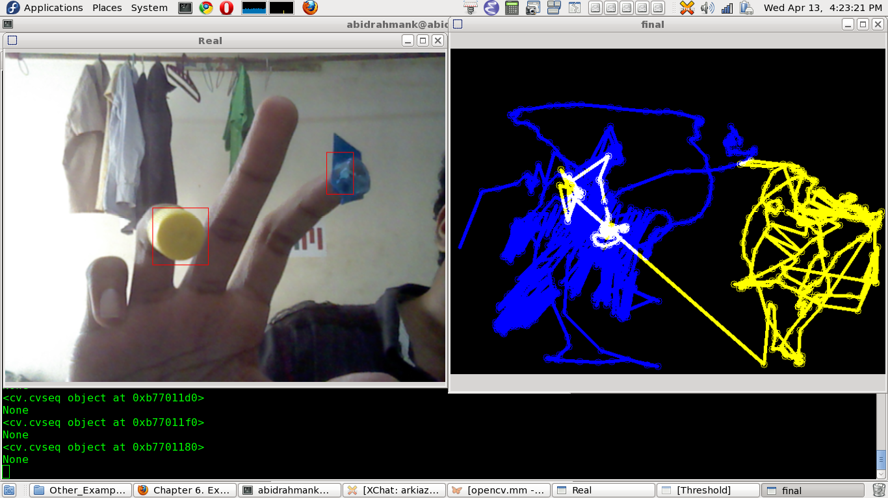

Fig3.16 problem that arose on Python Open CV wind

**Level 0 for working**

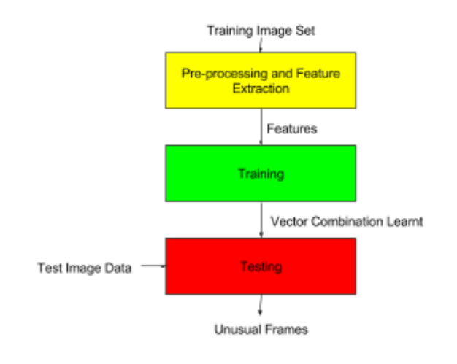

Fig 3.19 Working flow chart

**Level 1**

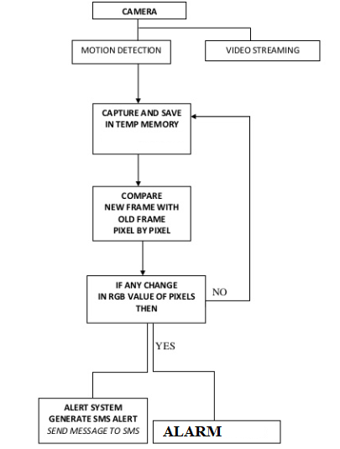

**CHAPTER 4**

**SYSTEM DESIGN**

**System Analysis**

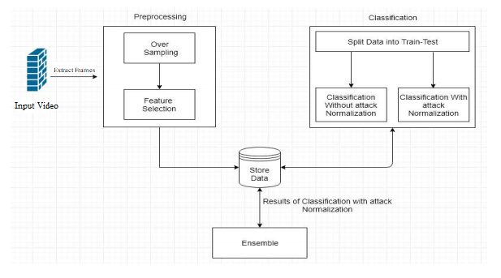

Once unusual event is detected, the surveillance system can be automated in such a way that it automatically locks the door of that particular ATM and sends the alarming message to security personnel present in the common observation room so that necessary action could be taken. We can use panic switch to alert the local people. ATM by detecting the human motion so that we can conserve the electricity. Alert mail is triggered on unusual activity detection to the concerned security agency office mail address; the Agency should have a 24X7 customer care security support (Control Room). Alert message is sent to the security guards as well.

**Moving Object Detection**

Moving object detection has various applications. Video surveillance is one of the Applications among them that is used to detectchanges in the scene.

**Preprocessing**: Some pre-processing is applied on the frames of the video to reduce noise. There are some common methods of preprocessing as in: Smooth Dilate, Erode, Median, Open, Close etc.

**Classification**

In this step any significant changes in the image region from backgroundmodel are identified& then pixels constituting the regions undergoing change are marked for further processing. Usually connected component labeling algorithm isapplied to obtain connected regions corresponding to the object.

**Classification normalization processing**: Finally, post processing is done to improve the results. There are many post processing techniques that can be used after background modeling and subtraction. These techniques have an objective to improve foreground mask.

**Classification notnormalization processing**: This is the final step in the process which extracts the moving object from the frame the result of this step helps in the judgment of the efficiency of the background subtraction system.

**CHAPTER 3**

**SYSYEM REQUIREMENTS SPECIFICATION**

**System Analysis**

**Moving Object Detection**

Moving object detection has various applications. Video surveillance is one of the applications among them that is used to detect changes in the scene. There are several schemes available to detect such changes. They are temporaldifferencing and Background modeling and subtraction.

1) Temporal Differencing - simple, low cost.

2).Background modeling and subtraction-most successful, used in both static and dynamic

Backgrounds.

Background subtraction is basically used to detect moving objects in videos using cameras.

The basic idea in this approach is detecting the moving objects from the difference between the

current frame and the reference frame, which is called “background modeling” or “background image”.

**B.Object Tracking**

Obtaining correct tracking information of moving foreground object is a difficult task in events like activity recognition and modeling. Forthis purpose many different types of algorithm have been used. These algorithms are divided into four different groups .They are Contour based, Model based, Feature based, Region based.

**C...Event Recognition**

Event recognition is the ultimate purpose of a fully automated video surveillance system. It is not an easy task to define the type of motion that is meaningful in video surveillance system. In event recognition the objects are detected by using background subtraction and then their boundaries are extracted to produce a skeleton. This skeleton structure provides important motion cues such as body posture etc. Motion activities of segmented blobs can be utilized in event recognition and detection such as fight or theft, walking or running, overcrowding etc.

**D. Object Identification**

In Object Identification the problem of “who is now entering the area under surveillance” is of increasing importance for video surveillance. Latest studies focus on personal identification and are based on biometrics such as Face and gait. Human gait and face are now regarded as the main biometric features that can beused for person identification in video surveillance systems.

**INPUT/OUTPUT Design**

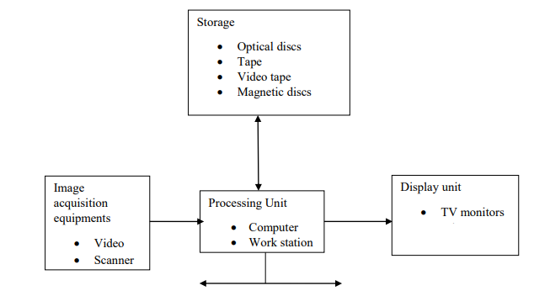

Sequence Diagram:

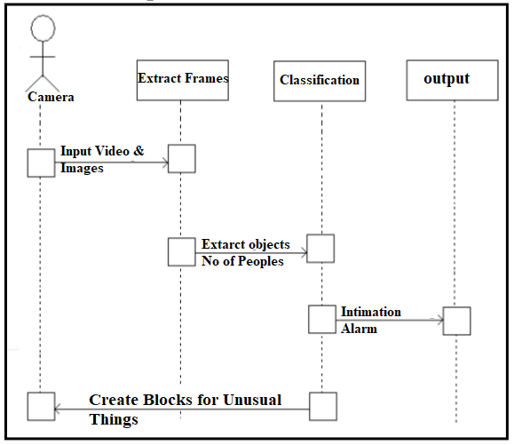

**Class Diagram:**

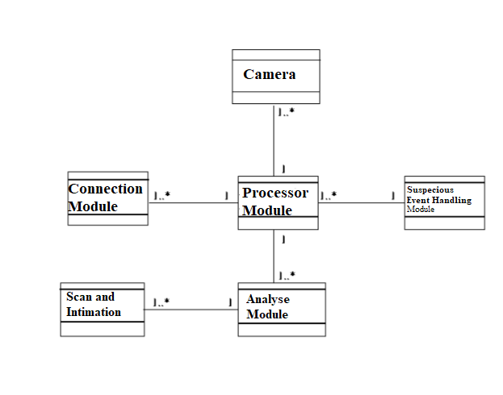

Use Case Diagram:

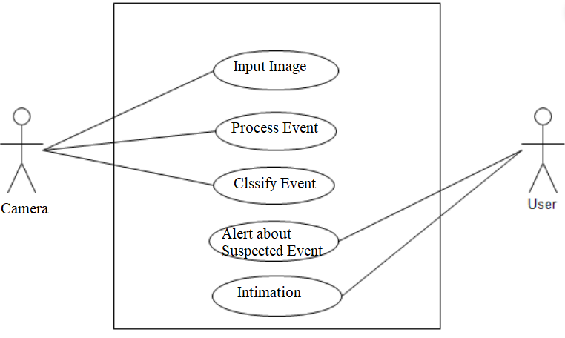

Activity Diagram:

s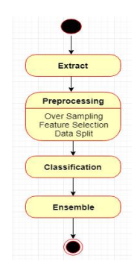

State Chart Diagram:

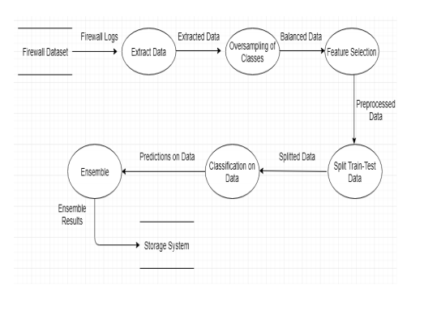

**CONCLUSION**

We thus developed an ATM model that is more reliable in providing security by using facial recognition software. By keeping the time elapsed in the verification process to a negligible amount we even try to maintain the efficiency of this ATM system to a greater degree. Biometrics as means of identifying and authenticating account owners at the Automated Teller Machines gives the needed and much anticipated solution to the problem of illegal transactions. In this project, we have tried to proffer a solution to the much dreaded issue of fraudulent transactions through Automated Teller Machine by biometrics that can be made possible only when the account holder is physically present. Thus, it eliminates cases of illegal transactions at the ATM points without the knowledge of the authentic owner. Using a biometric feature for identification is strong and it is further fortified when another is used at authentication level.

**REFERENCES**

[1] SudhirGoswami, JyotiGoswami, Nagresh Kumar, “Unusual Event Detection in Low Resolution Video for enhancing ATM security”, 2nd International Conference on Signal Processing and Integrated Networks (SPIN), 2015.

[2] Saleem Ulla Shariff ; MaheboobHussain ; Mohammed FarhaanShariff, “Smart unusual event detection using low resolution camera for enhanced security”, 2017 International Conference on Innovations in Information, Embedded and Communication Systems (ICIIECS), 17-18 March 2017

[3] Jignesh J. Patoliya ; Miral M. Desai, “Face detection based ATM security system using embedded Linux platform”, 2017 2nd International Conference for Convergence in Technology (I2CT), 7-9 April 2017.

[4] SharayuSadashivPhule ; Sharad D. Sawant, “Abnormal activities detection for security purpose un attainded bag and crowding detection by using image processing”, 2017 International Conference on Intelligent Computing and Control Systems (ICICCS), 15-16 June 2017.

[5] G. Renee Jebaline, S. Gomathi, “A Novel Method to Enhance the Security of ATM using Biometrics,” 2015 International Conference on Circuit, Power and Computing Technologies [ICCPCT] 978-1-4799- 7075-9/15/$31.00 ©2015 IEEE.

[6] Vikas Tripathi, Durgaprasad Gangodkar, Vivek Latta, and Ankush Mittal, “Robust Abnormal Event Recognition via Motion and ShapeAnalysis at ATM Installations”, Journal of Electrical and Computer Engineering, Volume 2015.

[7] S.Shriram, Swastik B.Shetty, Vishnuprasad P. Hegde , KCR Nisha, Dharmambal V , “ Smart ATM Surveillance System”, 2016 International Conference on Circuit, Power and Computing Technologies [ICCPCT]